
About | Contact | Twitter | TV | Radio | RSS | Newsletters | Archives | TreeHugger Book

US Missing Out On Agricultural Millions Because The DEA Can't Distinguish Hemp From Pot

by Matthew McDermott, New York, NY on 05. 4.11
Food & Health
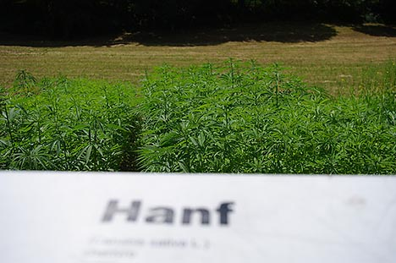
photo: mhaller1979/Creative Commons
In case you missed it (and you certainly may have in the midst of other current world affairs) it's Hemp History Week. The second annual one in fact. I imagine most TreeHugger readers don't need much convincing that the US ought to legalize industrial hemp production--remember, though it's perfectly legal to important hemp products into the US, it's illegal under Federal law to grow hemp--so I won't regale you with all the reasons I think hemp prohibition (alongside marijuana prohibition) is, to be blunt, moronic.
Rather here are some choice factoids I picked up from the Hemp History Week, Vote Hemp, and Candle 79 folks as I was fed a hemp-heavy vegan lunch on Manhattan's Upper East Side.
Hemp's Really Good Food
One of the foci of the latest campaign to tout the many virtues of hemp is the nutritional benefits. So factoid #1: In addition to being an excellent source of protein, hemp seed have a "perfectly balanced 1:3 ratio of naturally-occurring omega-3 and omega-6 essential fatty acids...unlike other seeds and nutritional oils, such as flax and fish fish oil, hemp seeds also contain super omega-3 stearidonic acid and super omega-6-gamma-linolenic acid in nutritionally relevant amounts that help to reduce inflammation and improve mental functioning, as well as make up for potentially impaired fatty acid metabolism."
In other words, while it's probably not a good idea to rely solely on hemp seed for these nutrients (as dietician Ashley Koff reminded us at Candle 79), a more balanced intake being preferable, hemp seed is seriously good for you.
US Is Missing Out in Millions of Dollars From Hemp Prohibition
Factoid #2: The United States is the only industrialized nation where growing industrial hemp is illegal. And because of that we're missing out on huge economic opportunity. Not insignificant when we're in less than ideal economic conditions and the potential for hemp is huge. Retail sales of hemp products in the US were $400 million in 2010 (so Vote Hemp tells me)--with $0 of the raw materials produced in the US. Based on Canadian stats, an acre of hemp is worth $200-400; and acre of soy or corn just $50.
Apparently even though Canadian cops can tell the difference between high-THC cannabis plants (marijuana) and low-THC plants (industrial hemp), the US DEA can't be bothered.
Ron Paul Supports Hemp Legalization
And, factoid #3 -- what's being done to rectify the situation. For environmentalists some support is coming from a seemingly unlikely quarter (considering his opposition to government regulating industry and greenhouse gas emissions, though the view is consistent), Ron Paul (R-TX).
Paul has submitted, for the second year in a row, an official Congressional Record statement in support of industrial hemp legalization. The last time Paul did this 25 additional members of Congress signed on.
What can you do? On the Hemp History Week site you can sign your name to letters to both President Obama and Attorney General Eric Holder urging them to let US farmers grow industrial hemp.
Happy Hemp History Week everyone.
More on Hemp
Perfect Plant? 7 Great Uses For Industrial Hemp
Victory for Hemp! Oregon Legalizes Industrial Hemp Production

